§3.9 Two dimensional linear flow
A two-dimensional linear system is a system of the form
$\begin{matrix}\overset{˙}{x}=\text{ax}+\text{by} \\ \overset{˙}{y}=\text{cx}+\text{dy}\end{matrix}$ $(9\text{.}1)$
where $a,\begin{matrix}\end{matrix}$ are parameters. $(9\text{.}1)$ can be written in vector form
$$\overset{˙}{X}=\text{AX}$$
where
$A=\left(\begin{matrix}a & b \\ c & d\end{matrix}\right)$ and $X=\left(\begin{matrix}x \\ y\end{matrix}\right)$ $(9\text{.}2)$
Such a system is a linear in the sense that if $X_{1}(t)$ and $X_{2}(t)$ are solutions of $(9\text{.}2)$, then is any linear combination $c_{1}X_{1}(t)+c_{2}X_{2}(t)$. Assume $\text{det}A≠0$, then $X=0$is the unique equilibrium of $(9\text{.}2)$. The solution of $\overset{˙}{X}=\text{AX}$ can be visualized as trajectories moving on the $(x,y)$ plane, in this context called phase plane.
For the general solutions of $(9\text{.}2)$ we seek trajectories of the form
$X(t)=e^{λt}v$ $(9\text{.}3)$
where $v≠0$ is some fixed vector to be determined and $λ∈C$ to be determined. Substitute $(9\text{.}3)$ into $(9\text{.}2)$, we obtain ${λe}^{λt}v=e^{λt}\text{Av}$. Cancelling the nonzero scalar factor $e^{λt}$ yields
$\text{Av}=λv$ $(9\text{.}4)$
i.e. $(λ,v)$ is an eigenpair of $2×2$ matrix $A$. It is easy to find that the eigenvalues $λ_{1}$, $λ_{2}$ of $A$ are
$λ_{1}=\frac{τ+\sqrt{τ^{2}−4Δ}}{2}$, $λ_{2}=\frac{τ−\sqrt{τ^{2}−4Δ}}{2}$ $(9\text{.}5)$
where
$τ=\text{trace}(A)=a+d$, $Δ=\text{det}A=\text{ad}−\text{bc}$
If $λ_{1}≠λ_{2}$ then the corresponding eigenvectors $v_{1}$ and $v_{2}$are linearly independent. Any initial condition $X_{0}$ can be written as a linear combination of eigenvectors, say, $X_{0}=c_{1}V_{1}+c_{2}V_{2}$. This observation allows us to write down the general solution $X(t)$ as
$X(t)=c_{1}e^{λ_{1}t}V_{1}+c_{2}e^{λ_{2}t}V_{2}$ $(9\text{.}6)$
There are following cases for various $λ_{1}$ and $λ_{2}$.

Case 1: $λ_{1}$, $λ_{2}$ are real and $λ_{2}<λ_{1}$
Case 1a (Stable node) $λ_{2}<λ_{1}<0$
Let $L_{1}$, $L_{2}$ be the line generated by $V_{1}$, $V_{2}$respectively. Since $λ_{2}<λ_{1}<0$, $X(t)≈c_{1}e^{λ_{1}t}V_{1}$ as $t→∞$ and the trajectories are tangent to $L_{1}$
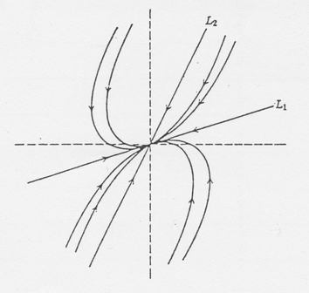
Case 1b (Unstable node) $0<λ_{2}<λ_{1}$
Then $X(t)≈c_{1}e^{λ_{1}t}V_{1}$ as $t→∞$
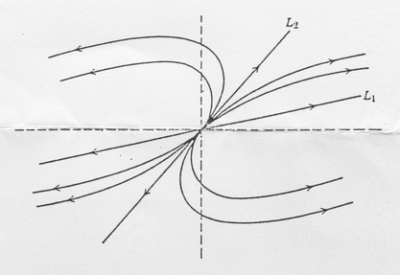
Case 1c (Saddle point) $λ_{2}<0<λ_{1}$. In this case, the origin 0 is called a saddle point and $L_{1}$, $L_{2}$ are unstable manifold and stable manifold.
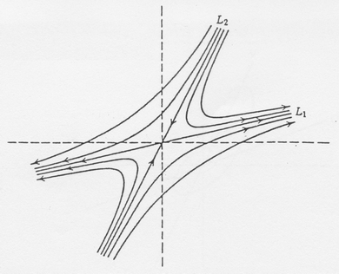
Case 2: $λ_{1}$, $λ_{2}$ are complex.
Let $λ_{1}=α+iβ$, $λ_{2}=α−iβ$ and $V_{1}=U+\text{iV}$ and $V_{2}=U+\text{iV}$ be complex eigenvectors. Then
$$x(t)={\text{ce}}^{(α+iβ)t}V_{1}+\bar{c}e^{(α−iβ)t}{\bar{V}}_{1}=2\text{Re}({\text{ce}}^{(α+iβ)t}V_{1})$$
Let $c={\text{ae}}^{iδ}$. Then
$x(t)=2{\text{ae}}^{αt}(u\text{cos}(βt+δ)−v\text{sin}(βt+δ))$.
Let $P$ and $Q$ be the line generated by $U$, $V$respectively.
Case 2a (Center) $α=0$, $β≠0$.
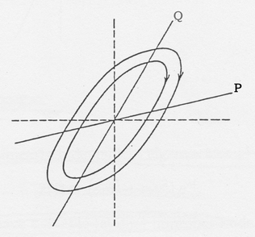
Case 2b (Stable focus, spiral) $α<0$, $β≠0$.
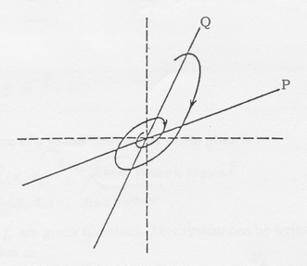
Case 2c (Unstable focus, spiral) $α>0$, $β≠0$.
