§3.6 Least square and curve fitting
For the linear system $\text{Ax}=b$, $A∈R^{m×n}$, $b∈R^{m}$ if the number $m$of observations is large than the number $n$ of unknowns then we expected that the system $\text{Ax}=b$ is inconsistent, i.e., there will not exist $x∈R^{n}$ satisfying the equation. Instead we consider the following least square problem:
$\underset{x∈R^{n}}{\text{min}}\left\|\text{Ax}−b\right\|$, $A∈R^{m×n}$, $b∈R^{m}$.
The minimum of errors, $E=\left\|A\bar{x}−b\right\|$ for some $\bar{x}$, is exactly the distance of point $b$ to the column space $ℜ(A)$
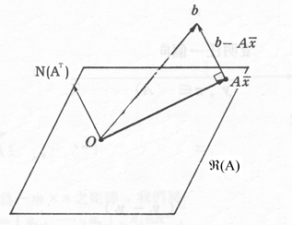
Geometrically the vector $b−A\bar{x}$ is perpendicular to the hyperplane $ℜ(A)$. From $(ℜ(A))^{}=N(A^{T})$, we have
$A^{T}(b−A\bar{x})=0$
or $\bar{x}$ satisfies the normal equation
$A^{T}A\bar{x}=A^{T}b$

Remark: The orthogonal projection of vector $b$ onto the hyperplane $ℜ(A)$ is $A\bar{x}$ which can be computed as
$A\bar{x}=A(A^{T}A)^{−1}A^{T}b=\text{Pb}$
where $P=A(A^{T}A)^{−1}A^{T}$ is called projection matrix. It can be verified that P satisfies
- It is idempotent: $P^{2}=P$
- It is symmetric: $P=P^{T}$
Least square fitting of data:
Suppose we do a series of experiments and expect the output $y$ to be pretty match a linear function of the input $t$, $y=C+\text{Dt}$. Assume we do $m$ experimentts at time $t_{1}$, $t_{2}$, $…$, $t_{m}$ with observations $y_{1}$, $y_{2}$, $…$, $y_{m}$. We wish these data satisfies
$C+{\text{Dt}}_{1}=y_{1}$
$⋮$
$C+{\text{Dt}}_{m}=y_{m}$
or
$\left[\begin{matrix}1 & t_{1} \\ ⋮ & ⋮ \\ 1 & t_{m}\end{matrix}\right]\left[\begin{matrix}C \\ D\end{matrix}\right]=\left[\begin{matrix}y_{1} \\ ⋮ \\ y_{m}\end{matrix}\right]$ or $\text{Ax}=b$
The best solution in the least square is the one that minimizes the sum of squares of errors; we choose $\bar{C}$ and $\bar{D}$to minimize
$E^{2}={\left\|b−A\bar{x}\right\|}^{2}=(y_{1}−C−{\text{Dt}}_{1})^{2}+⋯+(y_{m}−C−{\text{Dt}}_{m})^{2}$
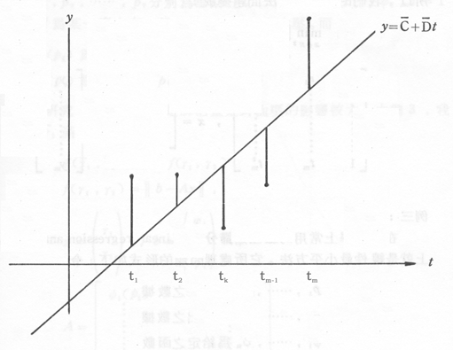

Remark: If we want to fit the data $(t_{1},y_{1})$, $…$, $(t_{m},y_{m})$ to the parabola $y=C_{0}+C_{1}t+C_{2}t^{2}$ then
$A=\left[\begin{matrix}1 & t_{1} & t_{1^{2}} \\ ⋮ & ⋮ & ⋮ \\ 1 & t_{m} & t_{m^{2}}\end{matrix}\right]$, $x=\left[\begin{matrix}C_{0} \\ C_{1} \\ C_{2}\end{matrix}\right]$, $b=\left[\begin{matrix}y_{1} \\ ⋮ \\ y_{m}\end{matrix}\right]$

