§3.5 Subspace and four fundamental subspaces
Definition 5.1: We say $W$ is a subspace of vector space $(V,∘,+)$ if
(i) $W⊂V$
- for any $α∈R$, $x∈W$, $αx∈W$
- for any $x,y∈W$, $x+y∈W$
Remark 5.1: A subspace $W$ of $R^{n}$ is a hyperplane passing through origin.
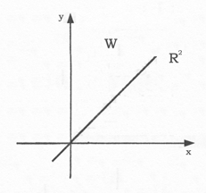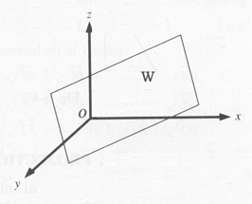
Given a $m×n$ matrix $A$, we shall define the following important subspaces
- $N(A)=$ is called null space of $A$ or Kernel of $A$, Ker$A$.
- $ℜ(A)$={$y∈R^{m}:\begin{matrix}y=\text{Ax}\end{matrix}$ for some $x∈R^{n}$} is the column space of $A$ since
$y=\text{Ax}=x_{1}a_{1}+⋯+x_{n}a_{n}$
- $N(A^{T})=$, the null space of $A^{T}$
- $ℜ(A^{T})$={$x∈R^{n}:\begin{matrix}x=A^{T}y\end{matrix}$, for some $y∈R^{m}$}, the row space of $A$.

Theorem 5.1: (Fundamental Theorem of Linear Algebra, Part I)
- $ℜ(A^{T})$= row space of $A$; dimension $r$
- $ℜ(A)$= column space of $A$; dimension $r$
- $N(A)$= null space of $A$; dimension $n−r$
- $N(A^{T})$= null space of $A^{T}$; dimension $m−r$
Hence for $A∈R^{m×n}$
dim$ℜ(A)$+ dim$N(A)$= $n$ $(5\text{.}1)$
Rank$A$= row rank of $A$= column rank of $A$ $(5\text{.}2)$

Example: Find the dimension and a basis of $ℜ(A)$, $N(A)$, $ℜ(A^{T})$, $N(A^{T})$ where
$A=\left[\begin{matrix}1 & 2 & 0 & 1 \\ 0 & 1 & 1 & 0 \\ 1 & 2 & 0 & 1\end{matrix}\right]→U=\left[\begin{matrix}1 & 2 & 0 & 1 \\ 0 & 1 & 1 & 0 \\ 0 & 0 & 0 & 0\end{matrix}\right]$
The basis of $ℜ(A)$ is {$(1,0,1)$, $(2,1,2)$} and dim$ℜ(A)$= 2. The dimension $N(A)$ is $4−2=2$. Solving $\text{Ax}=0$ is equivalent to $\text{Ux}=0$ or $x_{1}+2x_{2}+x_{4}=0$, $x_{2}+x_{3}=0$. Then $x_{4}=−x_{1}−2x_{2}$, $x_{3}=−x_{2}$. Treat $x_{1}$, $x_{2}$ as free variables
$\left(\begin{matrix}x_{1} \\ x_{2} \\ x_{3} \\ x_{4}\end{matrix}\right)=\left(\begin{matrix}x_{1} \\ x_{2} \\ −x_{2} \\ −x_{1}−2x_{2}\end{matrix}\right)=x_{1}\left(\begin{matrix}1 \\ 0 \\ 0 \\ −1\end{matrix}\right)+x_{2}\left(\begin{matrix}0 \\ 1 \\ −1 \\ −2\end{matrix}\right)$
Hence the basis of $N(A)$ is $(1,0,0,−1)^{T}$ and $(0,1,−1,−2)^{T}$.

Definition 5.2: Given a subspace $V$ of $R^{n}$, the space of all vectors orthogonal to $V$ is called the orthogonal complement of $V$ and denoted by $V^{}$ and $V⊕V^{}=R^{n}$.

Theorem 5.2: (Fundamental Theorem of Linear Algebra, Part 2)
For $m×n$ matrix $A$, we have
$N(A)=(ℜ(A^{T}))^{}$, $ℜ(A^{T})=N(A)^{}$
$N(A^{T})=(ℜ(A))^{}$, $ℜ(A)=(N(A^{T}))^{}$

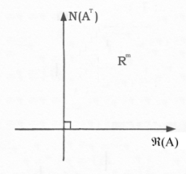

Theorem 5.3: (Fredholm Alternative)
For any $m×n$ matrix $A$ and $b∈R^{m}$, one and only one of the following systems has a solution:
(1) $\text{Ax}=b$ (2) $A^{T}y=0$, $y^{T}b≠0$
In other words, either $b$ is in column space $ℜ(A)$ or there is a $y∈N(A^{T})$ such that $y^{T}b≠0$

Remark 5.1: From $N(A^{T})=(ℜ(A))^{}$, it follows that $\text{Ax}=b$ is solvable if and only if $b⊥v$ for all $v∈N(A^{T})$.

