§3.13 Mathematical Model for Neuron Activity
The nervous system of an organism is a communication network that allows for rapid transmission of information between cells. It consists of nerve cells, called neurons. A typical neuron has a cell body that contains the cell nucleus and nerve fibers. Nerve fibers that receive information are called dendrites, those that transport information are called axons, which provide links to other neurons via synapses. A typical vertebrate neuron is shown in Figure 13.1.
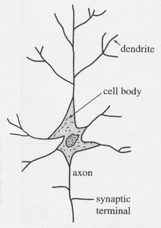
Figure 13.1 A typical vertebrate neuron.
Neurons respond to electrical stimuli; this response is exploited when studying neurons. When the cell body of an isolated neuron is stimulated with a very mild electrical shock, the neuron shows no response; increasing the intensity of the electrical shock beyond a certain threshold will trigger a response, namely an impulse that travels along the axon. Increasing the intensity of the electrical shock further does not change the response. This impulse is thus an all-or-none response.
A.L. Hodgkin and A.F. Huxley studied the giant axon of a squid experimentally, and developed a mathematical model for neuron activity. Their work appeared in a series of papers in 1952. It is an excellent example of how experimental and theoretical research can be combined to gain a thorough understanding of a natural system. In 1963, Hodgkin and Huxley were awarded the Nobel prize in physiology/medicine for their work on neurons.
We begin with a brief explanation of how a neuron works. The main players in the functioning of a neuron are sodium (Na⁺) and potassium (K⁺) ions. The cell membrane of a neuron is impermeable to sodium and potassium ions when the cell is in a resting state. In a typical neuron in its resting state, the concentration of Na⁺ in the interior of the cell is about one-tenth of the extracellular concentration of Na⁺; the concentration of K⁺ in the interior of the cell is about thirty times the extracellular concentration of K⁺. When the neuron is in its resting state, the interior of the cell is negatively charged (at –70mV) relative to the exterior of the cell.
When a nerve cell becomes stimulated, its surface becomes permeable to Na⁺ ions, which rush into the cell through sodium channels in the surface. This results in a reversal of polarization at the points where Na⁺ ions entered the cell. The surface inside the cell is now positively charged relative to the outside of the cell, and becomes permeable to K⁺ ions which rush outside through potassium channels. Because the potassium ions (K⁺) are positively charged and move from the inside to the outside of the cell, the polarization at the surface of the cell is again reversed, and is now below the polarization of the resting cell. To restore the original concentration of Na⁺ and K⁺ (and thus the original polarization), energy must be expended to run the so-called sodium and potassium pumps in the surface of the cell to pump the excess Na⁺ from the interior to the exterior of the cell and to pump K⁺ from the exterior to the interior of the cell.
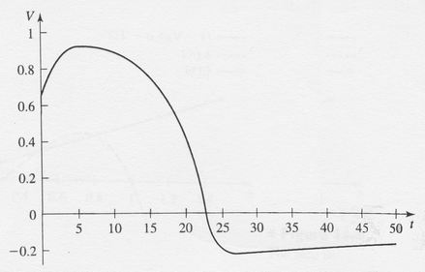
Figure 13.2 The action potential.
To trigger such a reaction, the intensity of the stimulus must be above a certain threshold. The described reaction occurs locally on the surface of the cell. This large local change in polarization triggers the same reaction in the neighborhood, which allows the reaction to propagate along the nerve cell—thus creating the observed impulse that travels along the cell. This localized large change in polarization, which is then reversed to the original polarization, is called an action potential. An example of an action potential is illustrated in Figure 13.2.
Hodgkin and Huxley measured sodium and potassium conductance and fitted curve to their data. The sodium curve is fitted by a cubic function and the potassium curve by a quartic function. They then developed a model for the action potential. The model consists of a system of four autonomous differential equations. It is a phenomenological model, that is, the equations are based on fitting curves to experimental data for the various components of the model. There is one equation that describes the change of voltage on the cell surface, two equations that describe the sodium channel, and one equation that describes the potassium channel. We will not give the details of this system, as it is far too complicated to analyze. (It is typically solved numerically.) Instead, we will present a simplified version of this model, which was developed by Fitzhugh (1961) and Nagumo et al. (1962).
The Fitzhugh-Nagumo model is based on the fact that the time scales of the two channels are quite different. The sodium channel works on a much faster time scale than the potassium channel. This fact led Fitzhugh and Nagumo to assume that the sodium channel is essentially always in equilibrium, which allowed them to reduce the four equations of the Hodgkin and Huxley model to two equations. The Fitzhugh-Nagumo model is thus an approximation to the Hodgkin and Huxley model. It retains the essential features of the action potential, but is much easier to analyze.
The Fitzhugh-Nagumo model is described by two variables. One variable, denoted by $V$, describes the potential of the cell surface. The other variable, denoted by $ω$, models the sodium and the potassium channels. The equations are given by
$$\frac{\text{dV}}{\text{dt}}=−V(V−a)(V−1)−ω$$ | $$(\text{13}\text{.}1)$$
$$\frac{dω}{\text{dt}}=b(V−cω)$$ | $$(\text{13}\text{.}1)$$
where $a$, $b$ and $c$ are constants that satisfy $0<a<1$, $b>0$ and $c>0$.
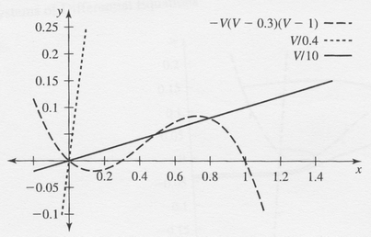
Figure 13.3 The zero isoclines of (11.66).
We will analyze the system graphically. The zero isoclines of $(\text{13}\text{.}1)$ are given by
$ω=−V(V−a)(V−1)$ and
The important feature of this model is that the zero isocline $\text{dV}\text{dt}=0$ is the graph of a cubic function in the $V−ω$ plane. The zero isoclines are illustrated in Figure 13.3.
We see that if $c$ is small, there is just one equilibrium, namely $(0,0)$; whereas when $c$ is sufficiently large, the line $ω=Vc$ intersects the graph of $\text{dV}\text{dt}=0$ three times.
The threshold phenomenon and the action potential are observed when $c$ is small. In this case, there is just one equilibrium, namely $(0,0)$, which corresponds to the resting state.
We can analyze the stability of $(0,0)$ by linearizing the system about this equilibrium. We find
$$Df(V,ω)=\left[\begin{matrix}−3V^{2}+2V+2\text{aV}−a & −1 \\ b & −\text{bc}\end{matrix}\right]$$
Hence,
$$Df(0,0)=\left[\begin{matrix}−a & −1 \\ b & −\text{bc}\end{matrix}\right]$$
To find the eigenvalues, we compute
$$\text{det}\left[\begin{matrix}−a−λ & −1 \\ b & −\text{bc}−λ\end{matrix}\right]=(−a−λ)(−\text{bc}−λ)+b=0$$
That is, we must solve
$$λ^{2}+(a+\text{bc})λ+b(\text{ac}+1)=0$$
which has solutions
$$\begin{matrix}λ_{1,2}=\frac{−(a+\text{bc})±\sqrt{(a+\text{bc})^{2}−4b(\text{ac}+1)}}{2} \\ \frac{−(a+\text{bc})±\sqrt{(a−\text{bc})^{2}−4b}}{2}\end{matrix}$$
Since $a$, $b$ and $c$ are positive constants, it follows that the expression under the square root, namely $(a+\text{bc})^{2}−4b(\text{ac}+1)$, is smaller than $(a+\text{bc})^{2}$. It therefore
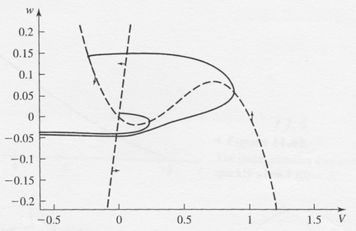
Figure 13.4 Solution curves for the Fitzhugh-Nagumo model.
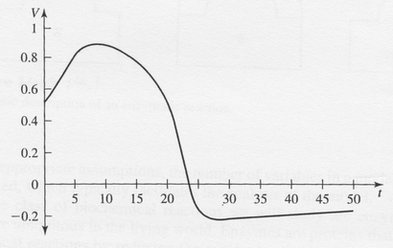
Figure 13.5 The action potential when $V(0)>a$.
follows that both $λ_{1}$ and $λ_{2}$ have negative real parts, which implies that $(0,0)$ is locally stable. As long as $(a−\text{bc})^{2}>4b$, the equilibrium is a stable sink. When $(a−\text{bc})^{2}<4b$, the eigenvalues are complex conjugates and $(0,0)$ becomes a stable spiral.
The system mimics the action potential when both eigenvalues are real and negative. If we apply a weak stimulus, that is, increase $V$ to a value less than $a$, $V$ will quickly return to 0. However, if we apply a strong enough stimulus, that is, $V∈(a,1)$, the trajectory will move away from the equilibrium point, as shown in Figure 13.4. A plot of voltage versus time reveals that if the stimulus is too weak, $V(t)$ will quickly return to the equilibrium, whereas if the stimulus is large enough, the solution curve of $V(t)$ resembles the action potential. In Figure 13.5 and 13.6, we present two solution curves $V(t)$. In either case, $ω(0)=0$. In Figure 13.5, $V(0)=0\text{.}5>a$, and we observe an action potential; whereas in Figure 13.6, $V(0)=0\text{.}2<a$, and the initial stimulus is too small and dies away quickly.
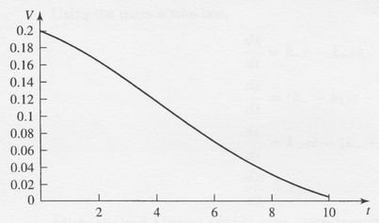
Figure 13.6 The initial stimulus dies away quickly when $V(0)<a$

