§3.12 Competition models, Mutualism or Symbiosis
The general $n$-species competition model is decribed by the following systems
$x_{1^{′}}=x_{1}f_{1}(x_{1}⋯x_{n})$
$⋮$
$x_{n^{′}}=x_{n}f_{n}(x_{1}⋯x_{n})$ $(\text{12}\text{.}1)$
$x_{i}(0)>0$, $i=1,\begin{matrix}\end{matrix}$
where $f_{i}(x_{1}⋯x_{n})$ satisfies
$\frac{∂f_{i}}{∂x_{j}}≤0$, $j≠i$.
In this section we first consider two-species competition model
$x_{1^{′}}=x_{1}f_{1}(x_{1},x_{2})$ $\frac{∂f_{1}}{∂x_{2}}≤0$,$\frac{∂f_{2}}{∂x_{1}}≤0$
$x_{2^{′}}=x_{2}f_{2}(x_{1},x_{2})$ $(\text{12}\text{.}2)$
Lotka-Volterra two-species competition model:
$\frac{{\text{dx}}_{1}}{\text{dt}}=γ_{1}x_{1}(1−\frac{x_{1}}{K_{1}})−α_{1}x_{1}x_{2}$
$\frac{{\text{dx}}_{2}}{\text{dt}}=γ_{2}x_{2}(1−\frac{x_{2}}{K_{2}})−α_{2}x_{1}x_{2}$ $(\text{12}\text{.}3)$
There are equilibria: $E_{0}=(0,0)$, $E_{1}=(K_{1},0)$ and $E_{2}=(0,K_{2})$. The interior equilibrian $E^{}=(x_{1^{}},x_{2^{}})$ exists under following case (iii) and (iv). The varational matrix at $E(x_{1},x_{2})$ is
$$A(x_{1},x_{2})=\left[\begin{matrix}γ_{1}(1−\frac{x_{1}}{K_{1}})−α_{1}x_{2}−\frac{γ_{1}}{K_{1}}x_{1}, & −α_{1}x_{1} \\ −α_{2}x_{2}, & γ_{2}(1−\frac{x_{2}}{K_{2}})−α_{2}x_{1}−\frac{γ_{2}}{K_{2}}x_{2}\end{matrix}\right]$$
At $E_{0}$,
$$A(0,0)=\left[\begin{matrix}γ_{1} & 0 \\ 0 & γ_{2}\end{matrix}\right]$$
$E_{0}$ is a source or a repeller.
At $E_{1}=(K_{1},0)$
$$A(K_{1},0)=\left[\begin{matrix}−γ_{1} & , & −α_{1}K_{1} \\ 0 & , & γ_{2}−α_{2}K_{1}\end{matrix}\right]$$
At $E_{2}=(0,K_{2})$
$$A(0,K_{2})=\left[\begin{matrix}γ_{1}−α_{1}K_{2} & , & 0 \\ −α_{2}K_{2} & , & −γ_{2}\end{matrix}\right]$$
There are four cases according to the position of isoclines L₁: $γ_{1}(1−\frac{x_{1}}{K_{1}})−α_{1}x_{2}$=0 and L₂: $γ_{2}(1−\frac{x_{2}}{K_{2}})−α_{2}x_{1}$=0
- Extinction case: species $y$ wins
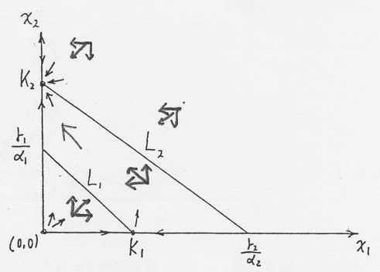

Figure 12.1
In this case $E_{2}=(0,K_{2})$ is a stable node, $E_{1}=(K_{1},0)$ is a saddle point and $E_{0}=(0,0)$ is a unstable node. It can be show that $\underset{t→∞}{\text{lim}}(x_{1}(t),x_{2}(t))=(0,K_{2})$.

- Extinction case: species $x_{1}$win,
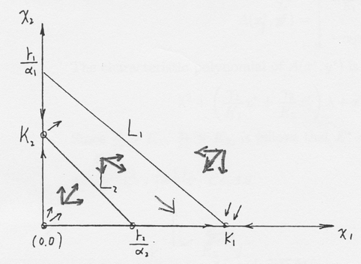

Figure 12.2
In this case $E_{1}=(K_{1},0)$ is a stable node, $E_{2}=(0,K_{2})$ is a saddle point and $E_{0}=(0,0)$ is an unstable node. It can be shown $\underset{t→∞}{\text{lim}}(x_{1}(t),x_{2}(t))=(K_{1},0)$

- Extinction case:
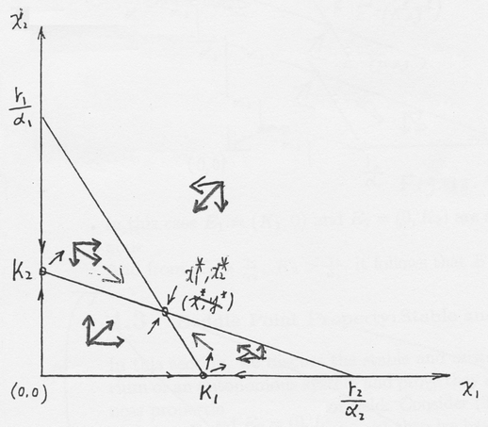

Figure 12.3
In this case $E_{1}=(K_{1},0)$ and $E_{2}=(0,K_{2})$ are saddle point, $E_{0}=(0,0)$ is an unstable node. It can be shown $\underset{t→∞}{\text{lim}}(x_{1}(t),x_{2}(t))=(x_{1^{}},x_{2^{}})$
The variational matrix for is
$$A(x_{1^{}},x_{2^{}})=\left[\begin{matrix}−\frac{γ_{1}}{K_{1}}x_{1^{}} & , & −α_{1}x_{1^{}} \\ −α_{2}x_{2^{}} & , & −\frac{γ_{2}}{K_{2}}x_{2^{}}\end{matrix}\right]$$
The characteristic polynomial of $A(x_{1^{}},x_{2^{}})$ is
$$λ^{2}+(\frac{γ_{1}}{K_{1}}x^{}+\frac{γ_{2}}{K_{2}}x_{2^{}})λ+x_{1^{}}x_{2^{}}(\frac{γ_{1}γ_{2}}{K_{1}K_{2}}−α_{1}α_{2})=0$$
Since $\frac{γ_{2}}{α_{2}}K_{1}$, $\frac{γ_{1}}{α_{1}}K_{2}$, it follows that $E^{}=(x_{1^{}},x_{2^{}})$ is a stable node.

- Bistable case
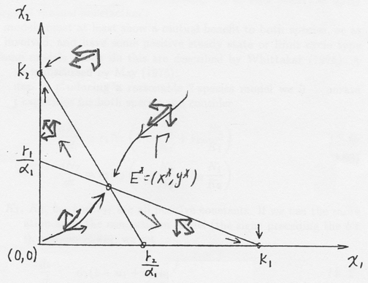

Figure 12.4
In this case $E_{1}=(K_{1},0)$ and $E_{2}=(0,K_{2})$ are stable node. $E_{0}=(0,0)$ is an unstable node.
And from $K_{1}>\frac{γ_{2}}{α_{2}}$, $K_{2}>\frac{γ_{1}}{α_{1}}$, it follows that $E^{}=(x_{1^{}},x_{2^{}})$ is a saddle point.
It can be shown that there exists an one-dimensional stable manifold $Γ$ of $E^{}=(x_{1^{}},x_{2^{}})$ such that every trajectory with initial condition on the left (right) hand of $Γ$ converges to $(0,K_{2})$ $((K_{1},0))$.

Mutualism or Symbiosis
There are many examples where the interaction of two or more species is to the advantage of all. Mutualism or symbiosis often plays the crucial role in promoting and even maintaining such species; plant and seed dispersers is one example. Even if survival is not at stake the mutual advantage of mutualism or symbiosis can be very important. As a topic of theoretical ecology, even for two species, this area has not been as widely studied as the others even though its importance is comparable to that of predator-prey and competition interactions. This is in part due to the fact that simple models on the Lotka-Volterra vein give silly results. The simplest mutualism model equivalent to the classical Lotka-Volterra predator-prey one is
$\frac{{\text{dN}}_{1}}{\text{dt}}=r_{1}N_{1}+a_{1}N_{1}N_{2}$, $\frac{{\text{dN}}_{2}}{\text{dt}}=r_{2}N_{2}+a_{2}N_{2}N_{1}$
where $r_{1}$, $r_{2}$, $a_{1}$ and $a_{2}$ are all positive contants. Since ${{\text{dN}}_{1}}/{\text{dt}}>0$ and ${{\text{dN}}_{2}}/{\text{dt}}>0$, $N_{1}$ and $N_{2}$ simple grow unboundedly in, as May (1981) so aptly puts it, ‘an orgy of mutual benefaction’.
Realistic models must at least show a mutual benefit to both species, or as many as are involved, and have some positive steady state or limit cycle type oscillation. Some models which do this are described by Whittaker (1975). A practical example is discussed by May (1975).
As a first step in producing a reasonable 2-species model we incorporate limited carrying capacities for both species and consider
$$\frac{{\text{dN}}_{1}}{\text{dt}}=r_{1}N_{1}(1−\frac{N_{1}}{K_{1}}+b_{\text{12}}\frac{N_{2}}{K_{1}})$$ | $$(\text{12}\text{.}4)$$
$$\frac{{\text{dN}}_{2}}{\text{dt}}=r_{2}N_{2}(1−\frac{N_{2}}{K_{2}}+b_{\text{21}}\frac{N_{1}}{K_{2}})$$ | $$(\text{12}\text{.}4)$$
where $r_{1}$, $r_{2}$, $K_{1}$, $K_{2}$, $b_{\text{12}}$ and $b_{\text{21}}$ are all positive constants. If we use the same nondimensionalization as in the competition model (the signs preceding the b’s are negative there), we get
$$\frac{{\text{du}}_{1}}{dτ}=u_{1}(1−u_{1}\text{++}a_{\text{12}}u_{2})=f_{1}(u_{1},u_{2})$$ | $$(\text{12}\text{.}5)$$
$$\frac{{\text{du}}_{2}}{dτ}={ρu}_{2}(1−u_{2}+a_{\text{21}}u_{1})=f_{2}(u_{1},u_{2})$$ | $$(\text{12}\text{.}5)$$
where
$u_{1}=\frac{N_{1}}{K_{1}}$, $u_{2}=\frac{N_{2}}{K_{2}}$, $τ=r_{1}t$, $ρ=\frac{r_{2}}{r_{1}}$, | $$(\text{12}\text{.}6)$$
$a_{\text{12}}=b_{\text{12}}\frac{K_{2}}{K_{1}}$, $a_{\text{21}}=b_{\text{21}}\frac{K_{1}}{K_{2}}$. | $$(\text{12}\text{.}6)$$
Analysing the model in the usual way we start with the steady states $(u_{1}^{},u_{2}^{})$ which from $(\text{12}\text{.}5)$ are
$(0,0)$, $(1,0)$, $(0,1)$, | $$(\text{12}\text{.}7)$$
$(\frac{1+a_{\text{12}}}{δ},\frac{1+a_{\text{21}}}{δ})$, positive if $δ=1−a_{\text{12}}a_{\text{21}}>0$. | $$(\text{12}\text{.}7)$$
After calculating the community matrix for $(\text{12}\text{.}5)$ and evaluating the eigenvalues $λ$ for each of $(\text{12}\text{.}7)$ it is straightforward to show that $(0,0)$, $(1,0)$ and $(0,1)$ and are all unstable: $(0,0)$ is an unstable node and $(1,0)$ and $(0,1)$ are saddle point equilibria. If $1−a_{\text{12}}a_{\text{21}}<0$ there are only 3 steady states, the first three in $(\text{12}\text{.}7)$ and so the populations become unbounded. We see this by drawing the null clines in the phase plane for $(\text{12}\text{.}5)$, namely, $f_{1}=0$, $f_{2}=0$ and noting that the phase trajectories move off to infinity in a domain in which $u_{1}→∞$ and $u_{2}→∞$ as in Fig.$(\text{12}\text{.}5)$(a).
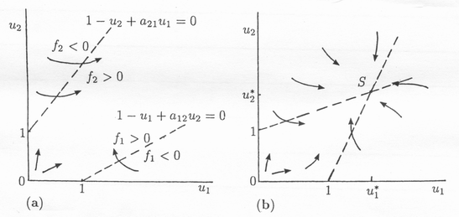
Figure 12.5 a, b. Phase trajectories for the mutualism model for 2 species with limited carrying capacities given by the dimensionless system $(\text{12}\text{.}5)$. (a) $a_{\text{12}}a_{\text{21}}>1$: unbounded growth occurs with $u_{1}→∞$ and $u_{2}→∞$ in the domain bounded by the null clines – the dashed lines. (b) $a_{\text{12}}a_{\text{21}}<1$: all trajectories tend to a positive steady state $S$ with $u_{1}^{}>1$, $u_{2}^{}>1$ which shows the initial benefit that accrues since the carrying capacities for each species is greater than if no interaction was presect.

When $1−a_{\text{12}}a_{\text{21}}>0$ the fourth steady state in $(\text{12}\text{.}7)$ exists in the positive quadrant. Evaluation of the eigenvalues of the community matrix shows it to be a stable equilibrium: it is a node singularity in the phase plane. This case is illustrated in Fig.$(\text{12}\text{.}5)$(b). Here all the trajectories in the positive quadrant tend to $u_{1}^{}>1$ and $u_{2}^{}>1$; that is $N_{1}>K_{1}$ and $N_{2}>K_{2}$ and so each species has increased its steady state population from its maximum value in islation.
This model has certain drawbacks. One is the sensitivity between unbounded growth and a finite positive steady state. It depends on the inequality $a_{\text{12}}a_{\text{21}}<1$, which from $(\text{12}\text{.}6)$ in dimensional terms is $b_{\text{12}}b_{\text{21}}<1$. So if symbiosis of either species is too large this last condition is violated and both populations grow unboundedly.

