§3.11 Predator-Prey models
Let $x(t)$ be the population density of prey, $y(t)$ be the population density of predator at time $t$. The general model for predator-prey interaction is following
$\frac{\text{dx}}{\text{dt}}=\text{xf}(x,y)$
$\frac{\text{dy}}{\text{dt}}=\text{yg}(x,y)$ $(\text{11}\text{.}1)$
$x(0)>0$, $y(0)>0$
Where $f(x,y)$ and $g(x,y)$ satisfy
$\frac{∂f}{∂y}≤0$, $\frac{∂g}{∂x}≥0$
In 1923 Volterra proposed a simple model to explain the oscillatory levels of a certain fish catches in Adriatic. The model takes the form
$\frac{\text{dx}}{\text{dt}}=\text{ax}−\text{bxy}$,
$\frac{\text{dy}}{\text{dt}}=\text{cxy}−\text{dy}$ , $(\text{11}\text{.}2)$
$x(0)>0$, $y(0)>0$.
In $(\text{11}\text{.}2)$ we assume the prey grows exponentially in the absence of predation. The prey is consumed by predator with the amount $\text{bxy}$ per unit time and is converted into the new population of predator at the rate $\text{cxy}$. $d$ is the death rate of predator. We note that $(\text{11}\text{.}2)$ was also derived by chemist Lotka in 1920 for the auto catalysis of chemical reaction $A→B$. $(\text{11}\text{.}2)$ is called Lotka-Volterra predator-prey model. In $(\text{11}\text{.}2)$ we have following equilibria: $(0,0)$, $(x^{},y^{})$ where $x^{}=\frac{d}{c}$, $y^{}=\frac{a}{b}$. Consider the Jacobian matrix of $(\text{11}\text{.}2)$ at $(x,y)$.
$J(E)=J(x,y)\left[\begin{matrix}a−\text{by} & −\text{bx} \\ \text{cy} & \text{cx}−d\end{matrix}\right]$
If $E=(0,0)$ then
$J(0,0)=\left[\begin{matrix}a & 0 \\ 0 & −d\end{matrix}\right]$
and $(0,0)$ is a saddle point with stable manifold $y$–axis and unstable manifold $x$–axis.
If $E=(x^{},y^{})$ then
$J(x^{},y^{})=\left[\begin{matrix}0 & −{\text{bx}}^{} \\ {\text{cy}}^{} & 0\end{matrix}\right]$
and $(x^{},y^{})$ is a center. The linearization provides no information for nonlinear system $(\text{11}\text{.}2)$.
Write $(\text{11}\text{.}2)$ as
$\frac{\text{dx}}{\text{dt}}=\text{bx}(y^{}−y)$
$\frac{\text{dy}}{\text{dt}}=\text{cy}(x−x^{})$
Elimination variable $t$, we obtain equation
$\frac{\text{dy}}{\text{dx}}=\frac{\text{dy}\text{dt}}{\text{dx}\text{dt}}=\frac{\text{cy}(x−x^{})}{−\text{bx}(y−y^{})}$, $(\text{11}\text{.}3)$
In $x$$y$ phase plane. From $(\text{11}\text{.}3)$ we have
$\frac{x−x^{}}{x}\text{dx}+\frac{b}{c}\frac{y−y^{}}{y}\text{dy}=0$, $(\text{11}\text{.}4)$
Integrate $(\text{11}\text{.}4)$ we obtain
$$V(x,y)=\int{\frac{ξ−x^{}}{ξ}dξ}+\frac{b}{c}\int{\frac{η−y^{}}{η}dη}\text{const}\text{.}$$
or
$$V(x,y)=(x−x^{}−x^{}\text{ln}\frac{x}{x^{}})+\frac{b}{c}(y−y^{}−y^{}\text{ln}\frac{y}{y^{}})$$
$H$
Then each solution of $(\text{11}\text{.}2)$ is a periodic solution and we obtain a series of “neutral” stable closed curves in $x$$y$ plane (See Fig 11.1).
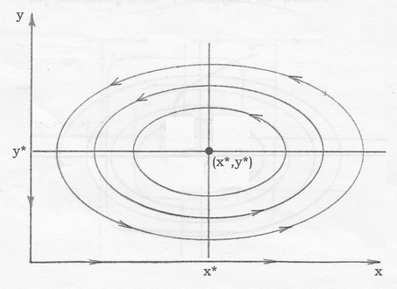
Figure 11.1
If we assume the prey grows logistically with carrying capacity $K$ in the absence of predation, then the predator-prey model takes the form
$\frac{\text{dx}}{\text{dt}}=\text{rx}(1−\frac{x}{K})−\text{bxy}$,
$\frac{\text{dy}}{\text{dt}}=\text{cxy}−\text{dy}$ , $(\text{11}\text{.}5)$
$x(0)>0$, $y(0)>0$.
Then there are two cases
Case 1: $β=\frac{d}{c}>K$
Then there are two euqilibria: $(0,0)$ which is a saddle, $(K,0)$ which is a stable. From the isocline analysis we predict $(K,0)$ is global stable, i.e., every solution of $(\text{11}\text{.}5)$ approach $(K,0)$ as $t→∞$ (See Fig. 11.2).
Case 2: $β=\frac{d}{c}<K$
Then there are three equilibria: $(0,0)$ which is a saddle, $(K,0)$ which is a saddle and $(x^{},y^{})$, $x^{}=β=\frac{d}{c}$, $y^{}=\frac{r}{b}(1−\frac{x^{}}{K})$ which is stable. From the isocline analysis we predict that $(x^{},y^{})$ is global stable.
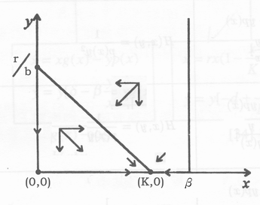
Figure 11.2
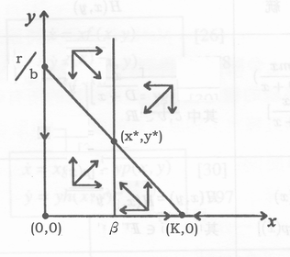
Figure 11.3
Remark:
There are five distinct types of biological interactions between two species:
- Mutualism or symbiosis (++): Each species has a positive effect on the other.
- Competition (--): Each species has a negative effect on the other.
- Commensalism (+0): One species benefits from the interaction, whereas the other is unaffected.
- Amensalism (-0): One species is negatively affected, whereas the other is unaffected.
- Predation (+0): One species benefits, whereas the other is negatively affected.

