Chapter 3 Linear algebra with applications in biology
§3.1 Basic operations of vectors
A vector $V$ space is a triple $(V,+,⋅)$ where $+$ is the addition and is a scalar multiplication. First we introduce the $n$-dimensional Euclidean space $R^{n}$, one of the most important vector spaces.
Let
$R^{n}=\left\{x=(x_{1},…,x_{n}):x_{i}∈R,i=1,2,…,n\right\}$.
Define the addition of two vectors $x$ and $y$ as following:
$x=(x_{1},…,x_{n})$, $y=(y_{1},…,y_{n})$
$x+y=(x_{1}+y_{1},…,x_{n}+y_{n})$.
The element $\vec{0}=(0,…,0)$ is the zero element of $R^{n}$. Obviously $x+\vec{0}=x$ for all $x∈R^{n}$. The geometric meaning of addition of two vectors is described as the following figure for case $n=2$:
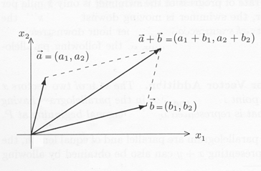

Figure 3.1.1
We define the scalar multiplication in $R^{n}$ as following. Let $α∈R^{n}$, $x=(x_{1},…,x_{n})∈R^{n}$. Define
$αx=({αx}_{1},…,{αx}_{n})$.
The geometric meaning of $αx$ is described as following
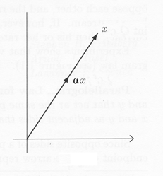

Figure 3.1.2
Next we introduce the inner product of two vectors $\vec{a}$, $\vec{b}∈R^{n}$. Define
$\vec{a}⋅\vec{b}=\sum_{i=1}^{n}{a_{i}b_{i}}$ or $(a,b)=\sum_{i=1}^{n}{a_{i}b_{i}}$
The length of the vector $\vec{a}∈R^{n}$ is defined as
$\left|\vec{a}\right|=\sqrt{\vec{a}⋅\vec{a}}=\sqrt{a_{1^{2}}+⋯+a_{n^{2}}}$
which is the distance between $\vec{a}$ and the origin $\vec{0}=(0,…,0)$. From law of cosine, we have (see Fig 3.1.3)
${\left|b−a\right|}^{2}={\left|\vec{a}\right|}^{2}+{\left|\vec{b}\right|}^{2}−2\left|a\right|\left|b\right|\text{cos}θ$.
On the other hand, we have
${\left|\vec{b}−\vec{a}\right|}^{2}$$=(\vec{b}−\vec{a})⋅(\vec{b}−\vec{a})=\vec{a}⋅\vec{a}−2\vec{a}⋅\vec{b}+\vec{b}⋅\vec{b}$
$$={\left|a\right|}^{2}+{\left|b\right|}^{2}−2\vec{a}⋅\vec{b}$$
Hence
$\vec{a}⋅\vec{b}=\left|a\right|\left|b\right|\text{cos}θ$
Obviously if $θ=π/2$, i.e., $\vec{a}⊥\vec{b}$ then $\vec{a}⋅\vec{b}=0$
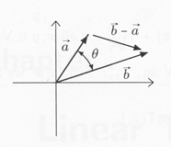

Fig 3.1.3

Example 1.1: Find the projection of vector $\vec{b}$ on the vector $\vec{a}$.
Ans: $\left|\vec{b}\right|\text{cos}θ\frac{\vec{a}}{\left|\vec{a}\right|}$
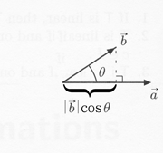
$=\left|\vec{a}\right|\left|\vec{b}\right|\text{cos}θ\frac{\vec{a}}{{\left|\vec{a}\right|}^{2}}$
$=\frac{\vec{a}⋅\vec{b}}{\vec{a}⋅\vec{a}}\vec{a}$

