§2.4 Periodic Windows
One of the most intriguing features of the orbit diagram (Figure 2.2.7) is the occurrence of periodic windows for $r>r_{∞}$. The period-3 window that occurs near $3\text{.}\text{8284}…≤r≤3\text{.}\text{8415}…$ is the most conspicuous. Suddenly, against a backdrop of chaos, a stable 3-cycle appears out of the blue. Our first goal in this section is to understand how this 3-cycle is created. (The same mechanism accounts for the creation of all the other windows, so it suffices to consider this simplest case.)
First, some notation. Let $f(x)=\text{rx}(1−x)$ so that the logistic map is $x_{n+1}=f(x_{n})$. Then $x_{n+2}=f(f(x_{n}))$ or more simply, $x_{n+2}=f^{2}(x_{n})$. Similarly, $x_{n+3}=f^{3}(x_{n})$.
The third-iterate map $f^{3}(x)$ is the key to understanding the birth of the period-3 cycle. Any point $p$ in a period-3 cycle repeats every three iterates, by definition, so such points satisfy $p=f^{3}(p)$ and are therefore fixed points of the third-iterate map. Unfortunately, since $f^{3}(x)$ is an eighth-degree polynomial, we cannot solve for the fixed points explicitly. But a graph provides sufficient insight. Figure 2.4.1 plots $f^{3}(x)$ for $r=3\text{.}\text{835}$.
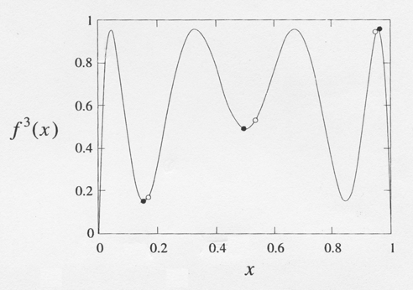
Figure 2.4.1
Intersections between the graph and the diagonal line correspond to solutions of $f^{3}(x)=x$. There are eight solutions, six of interest to us and marked with dots, and two impostors that are not genuine period-3; they are actually fixed points, or period-1 points for which $f(x^{})=x^{}$. The black dots in Figure 2.4.1 correspond to a stable period-3 cycle; note that the slope of $f^{3}(x)$ is shallow at these points, consistent with the stability of the cycle. In contrast, the slope exceeds 1 at the cycle marked by the open dots; this 3-cycle is therefore unstable.
Now suppose we decrease $r$ toward the chaotic regime. Then the graph in Figure 2.4.1 changes shape—the hills move down and the valleys rise up. The curve therefore pulls away from the diagonal. Figure 2.4.2 shows that when $r=3\text{.}8$, the six marked intersections have vanished. Hence, for some intermediate value between $r=3\text{.}8$ and $r=3\text{.}\text{835}$, the graph of $f^{3}(x)$ must have become tangent to the diagonal. At this critical value of $r$, the stable and unstable period-3 cycles coalesce and annihilate in a tangent bifurcation. This transition defines the beginning of the periodic window.
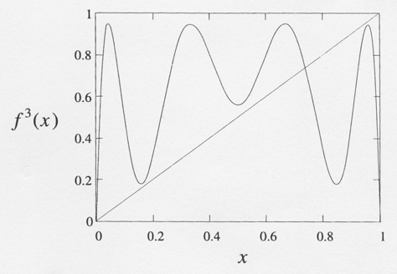
Figure 2.4.2
One can show analytically that the value of $r$ at the tangent bifurcation is $1+\sqrt{8}=3\text{.}\text{8284}…$ (Myrberg 1958). This beautiful result is often mentioned in textbooks and articles—but always without proof. Given the resemblance of this result to the $1+\sqrt{6}$ encountered in Example 3.3, I'd always assumed it should be comparably easy to derive, and once assigned it as a routine homework problem. Oops! It turns out to be a bear. See Exercise 10.4.10 for hints [1] p.393, and Saha and Strogatz (1994) for Partha Sana's solution, the most elementary one my class could find. Maybe you can do better; if so, let me know!

Intermittency
For $r$ just below the period-3 window, the system exhibits an interesting kind of chaos. Figure 2.4.3 shows a typical orbit for $r=3\text{.}\text{8282}$.
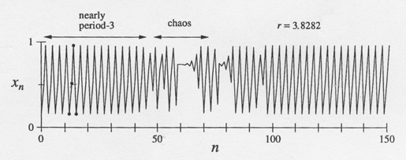
Figure 2.4.3
Part of the orbit looks like a stable 3-cycle, as indicated by the black dots. But this is spooky since the 3-cycle no longer exists! We' re seeing the ghost of the 3-cycle.
We should not be surprised to see ghosts—they always occur near saddle-node bifurcations and indeed, a tangent bifurcation is just a saddle-node bifurcation by another name. But the new wrinkle is that the orbit returns to the ghostly 3-cycle repeatedly, with intermittent bouts of chaos between visits. Accordingly, this phenomenon is known as intermittency (Pomeau and Manneville 1980).
Figure 2.4.4 shows the geometry underlying intermittency.
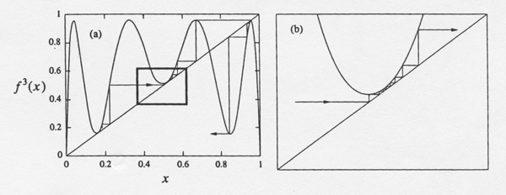
Figure 2.4.4
In Figure 2.4.4a, notice the three narrow channels between the diagonal and the graph of $f^{3}(x)$. These channels were formed in the aftermath of the tangent bifurcation, as the hills and valleys of $f^{3}(x)$ pulled away from the diagonal. Now focus on the channel in the small box of Figure 2.4.4a, enlarged in Figure 2.4.4b. The orbit takes many iterations to squeeze through the channel. Hence $f^{3}(x_{n})≈x_{n}$ during the passage, and so the orbit looks like a 3-cycle; this explains why we see a ghost.
Eventually, the orbit escapes from the channel. Then it bounces around chaotically until fate sends it back into a channel at some unpredictable later time and place.
Intermittency is not just a curiosity of the logistic map. It arises commonly in systems where the transition from periodic to chaotic behavior takes place by a saddle-node bifurcation of cycles. For instance, Exercise 10.4.8 in [1] p.392 shows that intermittency can occur in the Lorenz equations. (In fact, it was discovered there; see Pomeau and Manneville 1980).
In experimental systems, intermittency appears as nearly periodic motion interrupted by occasional irregular bursts. The time between bursts is statistically distributed, much like a random variable, even though the system is completely deterministic. As the control parameter is moved farther away from the periodic window, the bursts become more frequent until the system is fully chaotic. This progression is known as the intermittency route to chaos.
Figure 2.4.5 shows an experimental example of the intermittency route to chaos in a laser.
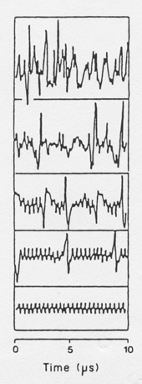
Figure 2.4.5 Harrison and Biswas (1986), p. 396
The intensity of the emitted laser light is plotted as a function of time. In the lowest panel of Figure 2.4.5, the laser is pulsing periodically. A bifurcation to intermittency occurs as the system's control parameter (the tilt of the mirror in the laser cavity) is varied. Moving from bottom to top of Figure 2.4.5, we see that the chaotic bursts occur increasingly often.
For a nice review of intermittency in fluids and chemical reactions, see Bergé et al. (1984). Those authors also review two other types of intermittency (the kind considered here is Type I intermittency) and give a much more detailed treatment of intermittency in general.

Period-Doubling in the Window
We commented at the end of Section 2 that a copy of the orbit diagram appears in miniature in the period-3 window. The explanation has to do with hills and valleys again. Just after the stable 3-cycle is created in the tangent bifurcation, the slope at the black dots in Figure 4.1 is close to +1. As we increase $r$, the hills rise and the valleys sink. The slope of $f^{3}(x)$ at the black dots decreases steadily from +1 and eventually reaches -1. When this occurs, a flip bifurcation causes each of the black dots to split in two; the 3-cycle doubles its period and becomes a 6-cycle. The same mechanism operates here as in the original period-doubling cascade, but now produces orbits of period 3-2". A similar period-doubling cascade can be found in all of the periodic windows.
Period 3 implies chaos and Sharkoskii ordering Li and Yorke in their paper [2] show that if a map $x_{n+1}=f(x_{n})$ has a 3-periodic point then the map has a $n$-periodic point for each $n$= 1, 2, $…$. During 1975~1985, the paper has big influence in promoting the scientific research in chaotic dynamics and its application. However the results in [2] is a special case of the work of Sharkoskii [3] in 1960. Define the Sharkovskii ordering by using the symbol $⊳$. Consider he ordering
$3⊳5⊳7⊳9⊳\text{11}⋯$ $⊳3⋅2⊳5⋅2⊳⋯$ $⊳3⋅2^{2}⊳5⋅2^{2}⊳⋯$ $⊳3⋅2^{3}⊳5⋅2^{3}⊳⋯$ $⊳2^{n+1}⊳2^{n}⊳⋯$ $⊳2⊳1$.
If the iterated map $x_{k+1}=f(x_{k})$ has a $p$–periodic point in above sequence, then the map has a $q$–periodic point for all $q$ satisfying $p⊳q$.

