§2.3 Logistic Map: Analysis
The numerical results of the last section raise many tantalizing questions. Let's try to answer a few of the more straightforward ones.

EXAMPLE 3.1:
Consider the logistic map $x_{n+1}={\text{rx}}_{n}(1−x_{n})$ for $0≤x_{n}≤1$ and $0≤r≤4$. Find all the fixed points and determine their stability.
Solution: The fixed points satisfy $x^{}=f(x^{})={\text{rx}}^{}(1−x^{})$. Hence $x^{}=0$ or $1=r(1−x^{})$, i.e., $x^{}=1−\frac{1}{r}$. The origin is a fixed point for all $r$, whereas $x^{}=1−\frac{1}{r}$ is in the range of allowable $x$ only if $r≥1$.
Stability depends on the multiplier $f^{'}(x^{})=r−2{\text{rx}}^{}$. Since $f^{'}(0)=r$ the origin is stable for $r<1$ and unstable for $r>1$. At the other fixed point, $f^{'}(x^{})=r−2r(1−\frac{1}{r})=2−r$. Hence $x^{}=1−\frac{1}{r}$ is stable for $−1<(2−r)<1$, i.e., for $1<r<3$. It is unstable for $r>3$. ○
The results of Example 3.1 are clarified by a graphical analysis (Figure 2.3.1). For $r<1$ the parabola lies below the diagonal, and the origin is the only fixed point. As $r$ increases, the parabola gets taller, becoming tangent to the diagonal at $r=1$. For $r>1$ the parabola intersects the diagonal in a second fixed point $x^{}=1−\frac{1}{r}$, while the origin loses stability. Thus we see that $x^{}$ bifurcates from the origin in a transcritical bifurcation at $r=1$ (borrowing a term used earlier for differential equations).
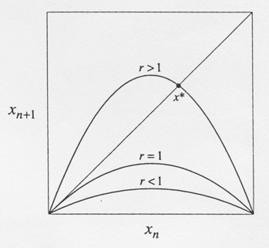
Figure 2.3.1
Figure 2.3.1 also suggests how $x^{}$ itself loses stability. As $r$ increases beyond 1, the slope at $x^{}$ gets increasingly steep. Example 3.1 shows that the critical slope $f^{'}(x^{})=−1$ is attained when $r=3$. The resulting bifurcation is called a flip bifurcation.
Flip bifurcations are often associated with period-doubling. In the logistic map, the flip bifurcation at $r=3$ does indeed spawn a 2-cycle, as shown in the next example.

EXAMPLE 3.2:
Show that the logistic map has a 2-cycle for all $r>3$.
Solution: A 2-cycle exists if and only if there are two points $p$ and $q$ such that $f(p)=q$ and $f(q)=p$. Equivalently, such a $p$ must satisfy $f(f(p))=p$, where $f(x)=\text{rx}(1−x)$. Hence $p$ is a fixed point of the second-iterate map $f^{2}(x)≡f(f(x))$. Since $f(x)$ is a quadratic polynomial, $f^{2}(x)$ is a quartic polynomial. Its graph for $r>3$ is shown in Figure 2.3.2.
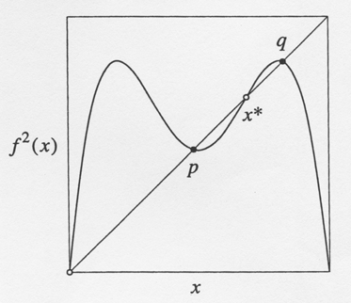
Figure 2.3.2
To find $p$ and $q$, we need to solve for the points where the graph intersects the diagonal, i.e., we need to solve the fourth-degree equation $f^{2}(x)=x$. That sounds hard until you realize that the fixed points $x^{}=0$ and $x^{}=1−\frac{1}{r}$ are trivial solutions of this equation. (They satisfy $f(x^{})=x^{}$, so $f^{2}(x^{})=x^{}$ automatically.) After factoring out the fixed points, the problem reduces to solving a quadratic equation.
We outline the algebra involved in the rest of the solution. Expansion of the equation $f^{2}(x)−x=0$ gives $r^{2}x(1−x)[1−\text{rx}(1−x)]−x=0$. After factoring out $x$ and $x−(1−\frac{1}{r})$ by long division, and solving the resulting quadratic equation, we obtain a pair of roots
$p,q=\frac{r+1±\sqrt{(r−3)(r+1)}}{2r}$,
Which are real for $r>3$. Thus a 2-cycle exists for all $r>3$, as claimed. At $r=3$, the roots coincide and equal $x^{}=1−\frac{1}{r}=\frac{2}{3}$, which shows that the 2-cycle bifurcates continuously from $x^{}$. For $r<3$ the roots are complex, which means that a 2-cycle doesn't exist. ○
A cobweb diagram reveals how flip bifurcations can give rise to period-doubling. Consider any map $f$, and look at the local picture near a fixed point where $f^{'}(x^{})≈−1$ (Figure 2.3.3).
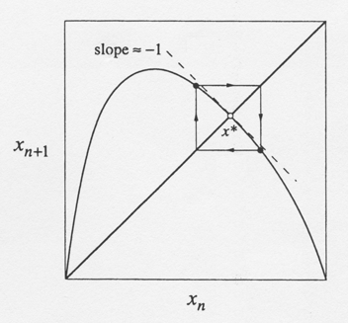
Figure 2.3.3
If the graph of $f$ is concave down near $x^{}$, the cobweb tends to produce a small, stable 2-cycle close to the fixed point. But like pitchfork bifurcations, flip bifurcations can also be subcritical, in which case the 2-cycle exists below the bifurcation and is unstable (Exercise).
The next example shows how to determine the stability of a 2-cycle.

EXAMPLE 3.3:
Show that the 2-cycle of Example 3.2 is stable for $3<r<1+\sqrt{6}=3\text{.}\text{449}…$.
Solution: Our analysis follows a strategy that is worth remembering: To analyze the stability of a cycle, reduce the problem to a question about the stability of a fixed point, as follows. Both $p$ and $q$ are solutions of $f^{2}(x)=x$, as pointed out in Example 3.2; hence $p$ and $q$ are fixed points of the second-iterate map $f^{2}(x)$. The original 2-cycle is stable precisely if $p$ and $q$ are stable fixed points for $f^{2}$.
Now we're on familiar ground. To determine whether $p$ is a stable fixed point of $f^{2}$, we compute the multiplier
$λ=\frac{d}{\text{dx}}(f(f(x)))_{x=p}=f^{'}(f(p))f^{'}(p)=f^{'}(q)f^{'}(p)$.
(Note that the same $λ$ is obtained at $x=q$, by the symmetry of the final term above. Hence, when the $p$ and $q$ branches bifurcate, they must do so simultaneously. We noticed such a simultaneous splitting in our numerical observations of Section 2.)
After carrying out the differentiations and substituting for $p$ and $q$, we obtain$λ$
$λ=r(1−2q)r(1−2p)$
$=r^{2}[1−2(p+q)+4\text{pq}]$
$=r^{2}[1−2(r+1)/r+4(r+1)/{r^{2}}]$
$=4+2r−r^{2}$.
Therefore the 2-cycle is linearly stable for $\left|4+2r−r^{2}\right|<1$ i.e., for $3<r<1+\sqrt{6}$. ○
Figure 2.3.4 shows a partial bifurcation diagram for the logistic map, based on our results so far. Bifurcation diagrams are different from orbit diagrams in that unstable objects are shown as well; orbit diagrams show only the attractors.
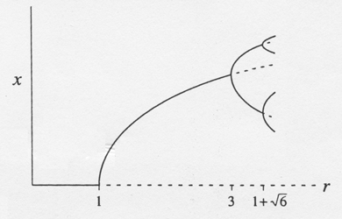
Figure 2.3.4
Our analytical methods are becoming unwieldy. A few more exact results can be obtained (see the exercises), but such results are hard to come by. To elucidate the behavior in the interesting region where $r>r_{∞}$, we are going to rely mainly on graphical and numerical arguments.

