§2.2 Logistic Map: Numerics
In a fascinating and influential review article, Robert May (1976) emphasized that even simple nonlinear maps could have very complicated dynamics. The article ends memorably with “an evangelical plea for the introduction of these difference equations into elementary mathematics courses, so that students’ intuition may be enriched by seeing the wild things that simple nonlinear equations can do.”
May illustrated his point with the logistic map
$x_{n+1}={\text{rx}}_{n}(1−x_{n})$, $(2\text{.}1)$
a discrete-time analog of the logistic equation for population growth. Here $x_{n}≥0$ is a dimensionless measure of the population in the $n$th generation and $r≥0$ is the intrinsic growth rate. As shown in Figure 2.2.1, the graph of $(2\text{.}1)$ is a parabola with a maximum value of $r4$ at $x=\frac{1}{2}$. We restrict the control parameter $r$ to the range $0≤r≤4$ so that $(2\text{.}1)$ maps the interval $0≤x≤1$ into itself.
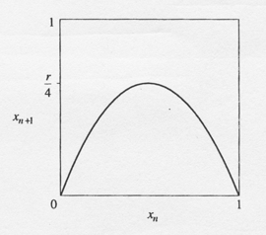
Figure 2.2.1

Period-Doubling
Suppose we fix $r$, choose some initial population $x_{0}$ and then use $(2\text{.}1)$ to generate the subsequent $x_{n}$. What happens?
For small growth rate $r<1$, the population always goes extinct: $x_{n}→0$ as $n→∞$. This gloomy result can be proven by cobwebbing (Exercise).
For $1<r<3$ the population grows and eventually reaches a nonzero steady state (Figure 2.2.2). The results are plotted here as a time series of $x_{n}$ vs. $n$. To make the sequence clearer, we have connected the discrete points $(n,x_{n})$ by line segments, but remember that only the corners of the jagged curves are meaningful.
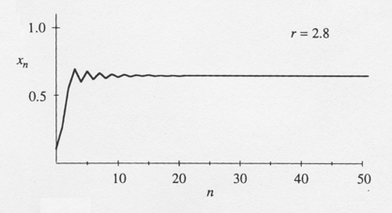
Figure 2.2.2
For larger $r$, say $r=3\text{.}3$, the population builds up again but now oscillates about the former steady state, alternating between a large population in one generation and a smaller population in the next (Figure 2.2.3). This type of oscillation, in which $x_{n}$ repeats every two iterations, is called a period-2 cycle.
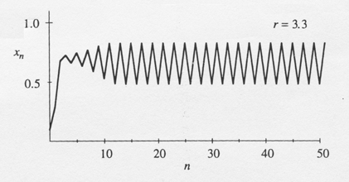
Figure 2.2.3
At still larger $r$, say $r=3\text{.}5$, the population approaches a cycle that now repeats every four generations; the previous cycle has doubled its period to period-4 (Figure 2.2.4).
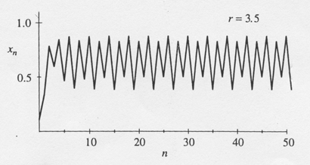
Figure 2.2.4
Further period-doublings to cycles of period 8, 16, 32, ..., occur as $r$ increases. Specifically, let $r_{n}$ denote the value of $r$ where a $2^{n}$-cycle first appears. Then computer experiments reveal that
 | $$r_{1}=3$$ | (period 2 is born)
 | $$r_{2}=3\text{.}\text{449}…$$ | 4
 | $$r_{3}=3\text{.}\text{54409}…$$ | 8
 | $$r_{4}=3\text{.}\text{5644}…$$ | 16
 | $$r_{5}=3\text{.}\text{568759}…$$ | 32
 | $$⋮$$ | $$⋮$$
 | $$r_{∞}=3\text{.}\text{569946}…$$ | $$∞$$
Note that the successive bifurcations come faster and faster. Ultimately the $r_{n}$ converge to a limiting value $r_{∞}$. The convergence is essentially geometric: in the limit of large $n$, the distance between successive transitions shrinks by a constant factor
$δ=\underset{n→∞}{\text{lim}}\frac{r_{n}−r_{n−1}}{r_{n+1}−r_{n}}=4\text{.}\text{669}…$.
We'll have a lot more to say about this number in Section 6.

Chaos and Periodic Windows
According to Gleick (1987, p. 69), May wrote the logistic map on a corridor blackboard as a problem for his graduate students and asked, “What the Christ happens for $r>r_{∞}$?” The answer turns out to be complicated: For many values of $r$, the sequence $\left\{x_{n}\right\}$ never settles down to a fixed point or a periodic orbit— instead the long-term behavior is aperiodic, as in Figure 2.2.5.
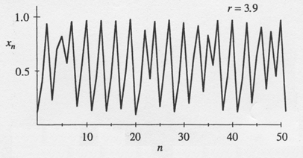
Figure 2.2.5
The corresponding cobweb diagram is impressively complex (Figure 2.2.6).
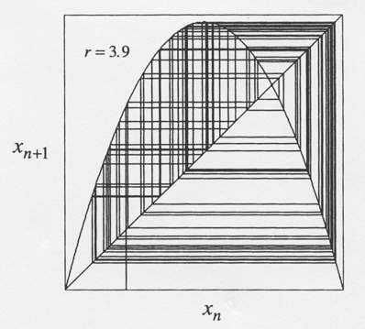
Figure 2.2.6
You might guess that the system would become more and more chaotic as $r$ increases, but in fact the dynamics are more subtle than that. To see the long-term behavior for all values of $r$ at once, we plot the orbit diagram, a magnificent picture that has become an icon of nonlinear dynamics (Figure 2.2.7). Figure 2.2.7 plots the system's attractor as a function of $r$. To generate the orbit diagram for yourself, you'll need to write a computer program with two “loops.” First, choose a value of $r$. Then generate an orbit starting from some random initial condition $x_{0}$. Iterate for 300 cycles or so, to allow the system to settle down to its eventual behavior. Once the transients have decayed, plot many points, say $x_{\text{301}},…,x_{\text{600}}$ above that $r$. Then move to an adjacent value of $r$ and repeat, eventually sweeping across the whole picture.
Figure 2.2.7 shows the most interesting part of the diagram, in the region $3\text{.}4≤r≤4$. At $r=3\text{.}4$, the attractor is a period-2 cycle, as indicated by the two branches. As $r$ increases, both branches split simultaneously, yielding a period-4 cycle. This splitting is the period-doubling bifurcation mentioned earlier. A cascade of further period-doublings occurs as $r$ increases, yielding period-8, period-16, and so on, until at $r=r_{∞}≈3\text{.}\text{57}$, the map becomes chaotic and the attractor changes from a finite to an infinite set of points.
For $r>r_{∞}$ the orbit diagram reveals an unexpected mixture of order and chaos, with periodic windows interspersed between chaotic clouds of dots. The large window beginning near $r≈3\text{.}\text{83}$ contains a stable period-3 cycle. A blow-up of part of the period-3 window is shown in the lower panel of Figure 2.2.7. Fantastically, a copy of the orbit diagram reappears in miniature!
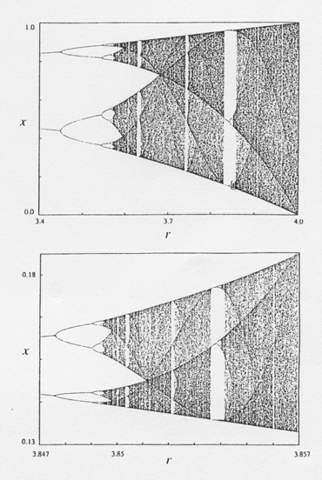
Figure 2.2.7 Campbell (1979), p. 35, courtesy of roger Eckhardt

