§1.4 Logistic equation
The simplest population model of single species is the Malthusim model. Let $N(t)$ be the population density of the species at time $t$. Assume the rate of change of the population is proportional to the current population. Let $N_{0}$ be the initial population, then we have
$\frac{\text{dN}}{\text{dt}}=\text{rN}$, $N(0)=N_{0}$, $r>0$ $(4\text{.}1)$
Then obviously $N(t)=N_{0}e^{\text{rt}}→∞$ as $t→∞$. $r$ is called the intrinsic growth rate of the species. Model $(4\text{.}1)$ is called the Malthusim model. It is used for the growth of species like bacteria in a nutrient-unlimited supplied environment. Verhulst (1804-1849) introduced the following logistic equation
$\frac{\text{dN}}{\text{dt}}=\text{rN}−{\text{bN}}^{2}$
$N(0)=N_{0}$ $(4\text{.}2)$
In $(4\text{.}2)$ the inter specific competition between the members of the species in the population is considered. It can be rewritten as
$\frac{\text{dN}}{\text{dt}}=\text{rN}(1−\frac{N}{K})$
$N(0)=N_{0}$ $(4\text{.}3)$
By separation of variable
$\frac{\text{dN}}{N(1−\frac{N}{K})}=\text{rdt}$
or
$(\frac{1}{N}+\frac{\frac{1}{K}}{1−\frac{N}{K}})\text{dN}=\text{rdt}$
Then
$\text{ln}\left|N\right|−\text{ln}\left|1−\frac{N}{K}\right|=\text{rt}+c$
Taking exponential on both sides we find that
$\frac{N}{1−(N/K)}={\text{Ce}}^{\text{rt}}$
Since $N(0)=N_{0}$ then $C={N_{0}}/[1−(\frac{N_{0}}{K})]$.
Then
$N(t)=\frac{N_{0}K}{N_{0}+(K−N_{0})e^{−\text{rt}}}$
Then for any $N_{0}>0$, $N(t)→K$ as $t→∞$. $K$ is called “carrying capacity” of the environment.
It is easy to see that if $N(t)<K/2$ then $N^{''}(t)>0$ while $N(t)>K/2$ implies $N^{''}(t)<0$. Hence the solution $N(t)$ has a typical sigmoid character with inflection point at $t_{0}$where $N(t_{0})=K/2$, which is commonly observed. If the inflection point is at $t_{0}$ satisfying $N(t_{0})=\frac{K}{θ+1}$, $0<θ≤1$, then we consider the following model due to Gilpin:
$\frac{\text{dN}}{\text{dt}}=\text{rN}(1−(\frac{N}{K}))^{θ}$ $(4\text{.}4)$
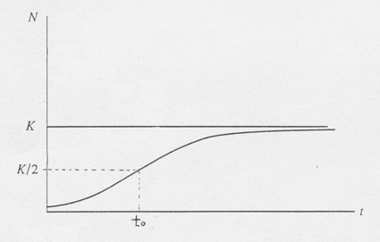
Figure 1.4.1
The one-dimensional flow of $(4\text{.}3)$ is
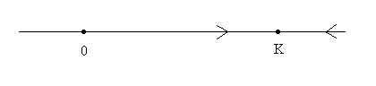
The equilibrium $x=0$ is unstable while the equilibrium $x=K$ is stable.

EXAMPLE 4.1: Levin’s metapopulation model
The ecological importance of spatially structured populations was pointed out by Andrewartha and Birch (1954) based on studies of insect populations. They observed that local populations become frequently extinct and subsequently recolonized. Fifteen years later, in 1969, Richard Levins introduced the concept of metapopulations (Levins 1969). This was a major theoretical advance; this concept provided a theoretical framework for studying spatially structured populations. Over the last ten years, the use of spatially structured population models has been firmly established in population biology.
A metapopulation is a collection of subpopulations. Each subpopulation occupies a patch, and different patches are linked via migration of individuals between patches. In this setting, one only keeps track of what proportion of patches are occupied by subpopulations. Subpopulations go extinct at a constant rate, denoted by $m$ ($m$ stands for mortality). Vacant patches can be colonized at a rate that is proportional to the fraction of occupied patches; the constant of proportionality is denoted by $c$ ($c$ stands for colonization rate). If we denote by $p(t)$ the fraction of patches that are occupied at time $t$, then writing $p=p(t)$,
$\frac{\text{dp}}{\text{dt}}=\text{cp}(1−p)−\text{mp}$ $(4\text{.}5)$
The first term on the right hand-side describes the colonization process. Note that an increase in the fraction of occupied patches occurs only if a vacant patch becomes occupied, hence the product $p(1−p)$in the first term on the right-hand side. The minus sign in front of $m$ shows that an extinction event decreases the fraction of occupied patches.
We will not solve $(4\text{.}5)$. Instead, we will analyze its equilibria. We set
$\text{cp}(1−p)−\text{mp}=0$
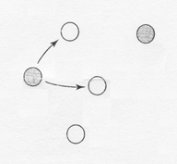

Figure 1.4.2
Then we have equilibria
$p_{1}=0$ and $p_{2}=1−\frac{m}{c}$
We call the solution $p_{1}=0$ a trivial solution because it corresponds to the situation in which all patches are vacant. Since individuals are not created spontaneously, a vacant patch can be recolonized only through migration from other occupied patches. Therefore, once a metapopulation is extinct, it stays extinct. The other equilibrium $p_{2}=1−m/c$ is only relevant when $p_{2}∈(0,1]$, because $p$ represents a fraction that is a number between 0 and 1. Since $m$ and $c$ are both positive, it follows immediately that $p_{2}<1$ for all choices of $m$ and $c$. To see when $p_{2}>0$, we check
$$1−\frac{m}{c}>0$$
which holds when
$$m<c$$
That is, the nontrivial equilibrium $p_{2}=1−m/c$ is in $(0,1]$ if the extinction rate $m$ is less than the colonization rate $c$. If $m≥c$, then there is only one equilibrium in $[0,1]$, namely $p_{1}=0$. We illustrate this in Figures 1.4.3 and 1.4.4, looking at the figures, it is easy to analyze the stability of the equilibria.
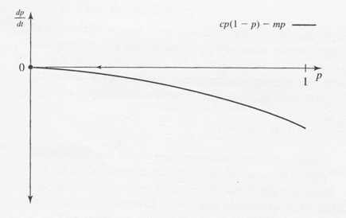

Figure 1.4.3 The case $m≥c$.
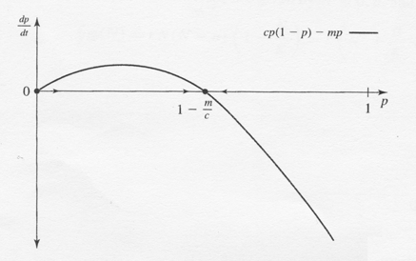
Figure 1.4.4 The case $m<c$.
Case I: $m≥c$
There is only the trivial equilibrium $p_{1}=0$. For any $p∈(0,1]$, we see that ${\text{dp}}/{\text{dt}}<0$, hence the fraction of occupied patches declines. The equilibrium is locally and globally stable.
Case II: $m<c$
There are two equilibria, namely 0 and $1−m/c$. The trivia equilibrium $p_{1}=0$ is unstable, since if we perturb $p_{1}=0$ to some value in $(0,1−m/c)$, then ${\text{dp}}/{\text{dt}}>0$, which implies that $p(t)$ increases. The system wit therefore not return to 0.
The other equilibrium, $p_{2}=1−m/c$, is locally stable. After a small perturbation of this equilibrium, to the right of $p_{2}$, ${\text{dp}}/{\text{dt}}<0$, and to the left of $p_{2}$, ${\text{dp}}/{\text{dt}}>0$; therefore, the system will return to $p_{2}$.
We can also analyze the stability of the equilibria. In addition, this will allow us to obtain information on how quickly the system returns to the stable equilibrium. We set
$f(p)=\text{cp}(1−p)−\text{mp}$

To linearize this function about the equilibrium values, we must find

$f^{'}(p)=c−2\text{cp}−m$

Now, if $p_{1}=0$, then
$f^{'}(0)=c−m$

whereas, if $p_{2}=1−m/c$, then
$$f^{'}(1−\frac{m}{c})=c−2c(1−\frac{m}{c})−m=c−2c+2m−m=m−c$$
We find that
if $c−m<0$ then $p_{1}=0$ is locally stable
if $m−c<0$ then $p_{2}=1−\frac{m}{c}$ is locally stable

Example 4.2: The Allee Effect
In a sexually reproducing species, individuals may experience a disproportionately low recruitment rate when the population density falls below a certain level, due to lack of suitable mates. This is called an Alice effect (see Allee 1931). A simple extension of the logistic equation incorporates this effect. We denote by $N(t)$ the size of a population at time $t$, then, writing $N=N(t)$
$\frac{\text{dN}}{\text{dt}}=\text{rN}(N−a)(1−\frac{N}{K})$ $(4\text{.}6)$
where $r$, $a$, and $K$ are positive constants. We assume that $0<a<K$. We will see that, as in the logistic equation, $K$ denotes the carrying capacity. The constant $a$ is a threshold population size, below which the recruitment rate is negative, meaning that the population will shrink and ultimately go to extinction.
The equilibria of $(4\text{.}6)$ are given by $\hat{N}=0$, $a$, and $K$. We set
$$f(N)=\text{rN}(N−a)(1−\frac{N}{K})=r(N^{2}+\frac{a}{K}N^{2}−\frac{N^{3}}{K}−\text{aN})$$

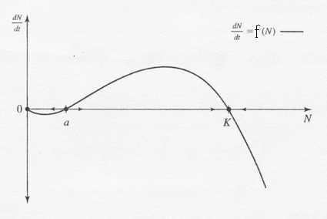

Figure 1.4.5 The graph of $f(N)$ for the Allee effect.

A graph of $f(N)$ is shown in Figure 1.4.5. Differentiating $f(N)$ yields
$$f^{'}(N)=r(2N+\frac{2a}{K}N−\frac{3N^{2}}{K}−a)=\frac{r}{K}(2\text{NK}+2\text{aN}−3N^{2}−\text{aK})$$
We can compute $f^{'}(\hat{N})$ associated with the equilibrium $\hat{N}$.
if $\hat{N}=0$ then $f^{'}(0)=\frac{r}{K}(−\text{aK})<0$
if $\hat{N}=a$ then $f^{'}(a)=\frac{r}{K}a(K−a)>0$
if $\hat{N}=K$ then $f^{'}(K)=\frac{r}{K}K(a−K)<0$
Since $f^{'}(0)<0$, it follows that $\hat{N}=0$ is locally stable. Likewise, since $f^{'}(K)<0$, it follows that $\hat{N}=K$ is locally stable. The eauilibrium $\hat{N}=a$ is unstable since $f^{'}(a)>0$. This is also evident from Figure 1.4.5. This is an example where both stable equilibria locally but not globally stable.
We see from Figure 1.4.5 if $0≤N<a$, then $N(t)→0$ as $t→∞$. If $a<N(0)≤K$ or $N(0)≥K$, then $N(t)→K$ as $t→∞$. To interpret our results, we see that if the initial population $N(0)$ is too small (that is, $N(0)<a$), then the population goes extinct. If the initial population is large enough (that is, $N(0)>a$), the population persists. That is, the parameter $a$ is a threshold level. The recruitment rate is only large enough when the population size exceeds this level.

In the following example we consider the evolution DNA sequence, the nucleotide substitution in a DNA sequence ([9] p.59).

Example 4.3: Jukes and Cantor’s one-parameter model
$α$
Purines A G

$α$ $α$ $α$
$α$
Pyrimidines C T
$α$

Assume that the nucleotide at certain site in a DNA sequence is $A$ at time $t=0$. Let $P_{A}(t)$ be the probability that this site will be occupied at time $t$. Let $α$ be the rate of substitution in each direction. Then
$\frac{{\text{dP}}_{A}}{\text{dt}}=−3{αP}_{A}(t)+α(1−P_{A}(t))$
$P_{A}(0)=1$
Then
$\frac{{\text{dP}}_{A}}{\text{dt}}=α(1−4P_{A}(t))$, $P_{A}(0)=1$
and
$P_{A}(t)=\frac{1}{4}+(P_{A}(0)−\frac{1}{4})e^{−4αt}$
If $P_{A}(0)=1$ then $P_{A}(t)=\frac{1}{4}+\frac{3}{4}e^{−4αt}$
If $P_{A}(0)=0$ then $P_{A}(t)=\frac{1}{4}−\frac{1}{4}e^{−4αt}$
We may also write
$P_{\text{AA}}(t)=$probability that the site is $A$ at time $t$ with initial site at $A$
$P_{\text{GA}}(t)=$probability that the site is $A$ at time $t$ with initial site at $G$
Hence
$P_{\text{ii}}(t)=\frac{1}{4}+\frac{3}{4}e^{−4αt}$
$P_{\text{ij}}(t)=\frac{1}{4}−\frac{1}{4}e^{−4αt}$ ($i,j=A,T,C,G$)

Remark: We may model nucleotide substitution in difference equation
$P_{A}(t+1)=(1−3α)P_{A}(t)+α(1−P_{A}(t))$

