§1.3 Phase “plane” analysis [2]: One-dimensional flow
Consider the autonomous equation
$\frac{\text{dx}}{\text{dt}}=f(x)$ $(3\text{.}1)$
Sometimes it is more important to understand the qualitative behavior of the solutions than finding the solutions in closed form.

EXAMPLE 3.1:
$\frac{\text{dx}}{\text{dt}}=\text{sin}x$
$\text{dt}=\frac{\text{dx}}{\text{sin}x}=\text{csc}\text{xdx}$
implies
$t=\int{\text{csc}\text{xdx}}=−\text{ln}\left|\text{csc}x+\text{cot}x\right|+C$
If $x(t_{0})=x_{0}$, then
$t=\text{ln}\left|\frac{\text{csc}x_{0}+\text{cot}x_{0}}{\text{csc}x+\text{cot}x}\right|$
We are unable to write down the solution $x(t)$ in closed form. However in the following figure 1.3.1 we have the flow on the phase line.
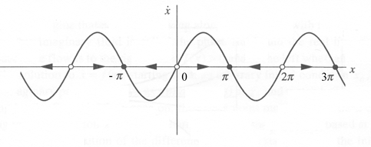
Figure 1.3.1
Set $f(x)=\text{sin}x$ then $f(nπ)=0$. ${\left\{nπ\right\}}_{n∈Z}$ are the equilibria of the equation of $(3\text{.}1)$. We say that $±π$, $±3π$, $…$ are stable equilibria and 0, $±2π$, $±4π$, $…$ are unstable equilibria. Since $f^{'}(x)=\text{cos}x$, $f^{'}((2n+1)π)=−1<0$ and $f^{'}(2nπ)\text{=+}1>0$. ○

Definition 3.1: $x^{}$ is called an equilibrium of $(3\text{.}1)$ if $f(x^{})=0$.
Consider the equilibrium $x^{}$ of $x^{'}=f(x)$. Do the Taylor expansion of $f(x)$ about $x^{}$,
$f(x)=f(x^{})+f^{'}(x^{})(x−x^{})+⋯$
$=f^{'}(x^{})(x−x^{})+⋯$
Let $y=x−x^{}$. Then
$y^{'}=\text{ay}+⋯$
where $a=f^{'}(x^{})$. Then
$y^{'}=\text{ay}$ $(3\text{.}2)$
is called the linearized equation about the equilibrium $x^{}$ for the equation $(3\text{.}1)$.

EXAMPLE 3.2:
Find all equilibria for $x^{'}=x(x−1)(x+1)$ and classify their stability
Solve: $f(x)=x(x−1)(x+1)=x^{3}−x$
$f^{'}(x)=3x^{2}−1$
The equilibria are $x^{}=0$, 1, -1
$f^{'}(0)=−1<0$, $f^{'}(1)=2>0$, $f^{'}(−1)>0$.
Hence $x=0$ is stable, $x=±1$ are unstable.
